BANYANews

Newsletter of The Banyan Trust
Year 7 Registered Charity No. 1071981 Company Limited by Guarantee No. 3610633 Autumn -2006
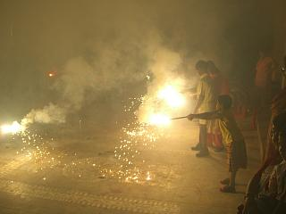
CHAIRMAN’S MESSAGE
Here is our Co-ordinator’s report as she endeavours to reach out to the community to share ideas and broaden the children’s horizons:

“The Regional Abilympics – Eastern Zone was held at the Indian Institute of Cerebral Palsy, Kolkata. Four students (Prem, Suvojeet, Soumik and Sadhan) from APANJAN participated there. The main objective of the Abilympics was to find the inner talent of the differently abled persons. Prem – first boy of APANJAN showed his excellent talent of Flower-arrangement division. On the last day Sudipta Dutta (Down Syndrome) – day care student – performed a beautiful dance programme which was appreciated by everyone.
Recently APANJAN has joined the Disability Activist Forum (DAF). There are 38 members in the Forum. It works for the rights of the differently abled persons. Any organization working for the disabled persons, parent of the disabled child. A differently abled individual can also get the membership from this Forum. Now DAF is very busy for an amendment of the Persons With Disability Act – 1995. And so they organized a workshop to understand the views of Government people, Non-Government people and others.
Arti, one of Apanjan’s residents with speech and hearing problems has now been admitted to a Government Primary School for formal education. APANJAN believes in Inclusive Education with a strong follow up. Arti feels good about going to formal school with other friends.” Somasree Das, October 2006

Good news, like this inspires me to try and find more ways of securing funds for these kids – any ideas?
Annie Larner, chairman.

HAPPY DIWALI !
On October 21st it was Diwali in India, the annual Festival of Lights, which is celebrated all over the country with fireworks and food. The village of Govindapur had generously donated a large amount of fireworks to the children of Apanjan. Under close supervision of the staff some children excitedly lit the fuses (Ajay and Ritu pictured above), whereas others were less pleased with the endless bangs, flares and smoke and eyed the event suspiciously from a safe distance.
The village’s largesse shows their support and enthusiasm for the Apanjan Project. Other welcome community support recently came from a local widow who passed away leaving 70,000 rupees (₤ 900) to Apanjan, in memory of her deceased son who had multiple disabilities. She has requested that the amount be spent on a “soft room”, as her own son always injured himself by compulsively banging his head against the wall. At the moment the soft room is being refurbished with soothing colours, padded walls and calming music. At Apanjan there are many children who have mobility problems and often trip and fall. Especially for them the soft room will be a place where they can potter around without injuring themselves. For other children, such as the ones who are hyper-active, it will be a good place to calm down.

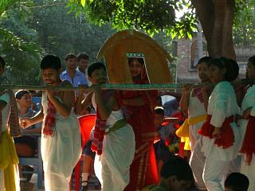

Children of Apanjan performing at a cultural programme on 23/10/2006.

Apanjan teacher visiting a local home.
and professional advice. The Apanjan staff also regularly visit the homes of students to monitor the involvement of the parents in the child’s development in their domestic environment and keep them directly informed of their child’s progress.

APANJAN AMBULANCE
Dr Sujan Chakraborty, a Member of Parliament, visited Apanjan earlier this year. He was so impressed with the project’s work that he decided to donate an ambulance. At a small ceremony he handed over the keys to Ritu and Prem. Apanjan is now able to provide the first and only ambulance service to the community. In case of a medical emergency the villagers can contact Apanjan and project driver Sanjay will transport the patient to the nearest hospital. The ambulance is also used as a mobile clinic for medical outreach to Apanjan students who are too ill to attend the day centre.
Apanjan would like to thank Dr Chakraborty for his generous contribution.

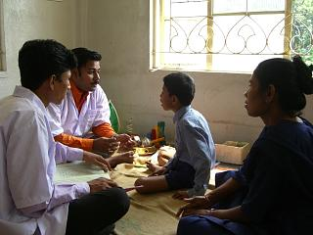
AUDIOLOGY, SPEECH & LANGUAGE
The audiologist and speech & language therapists of Apanjan plan individualized speech training programmes for children to develop their communication skills. The therapists hold training workshops for the parents in speech and language therapy. This makes the therapeutic intervention more effective at home and the parents also become aware of the “Do’s” and “Don’ts” in the management of children with special needs and the importance of consistency. The team of specialists from Ali Yavar Jung National Institute for the Hearing Handicapped (NIHH) held a very interesting and informative workshop for 45 parents, special teachers and therapists. While thanking them, we hope to receive continued support from them. From 70 students in our Day Care Centre – more than 53 children need speech therapy. Somasree Das, Project Coordinator of Apanjan

APANJAN OUTREACH
Apanjan has increased its outreach programme activities. At present the Day Centre has a waiting list of 100 children with multiple disabilities from poor families in the surrounding area. In order to provide assistance to the often desperate parents Apanjan’s special education experts and medical staff visit their homes to offer assessments and

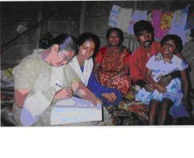

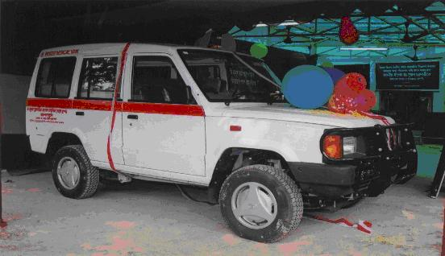

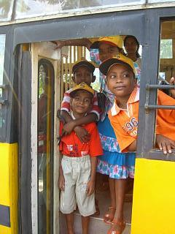
OUR WORK
Apanjan is a joint project of The Banyan Trust and its Indian partner organisation OFFER. Apanjan offers a home, education and medical care to children with multiple disabilities from disadvantaged backgrounds.
Our work would not be possible without the generous support of our regular sponsors.
For more information contact The Banyan Trust: 01438 358500.
Or email: annie@banyantrust.freeserve.co.uk
