BANYANews

Newsletter of The Banyan Trust
Year 9 Registered Charity No. 33306627 Spring 2008
BANYAN DHAKA, BANGLADESH
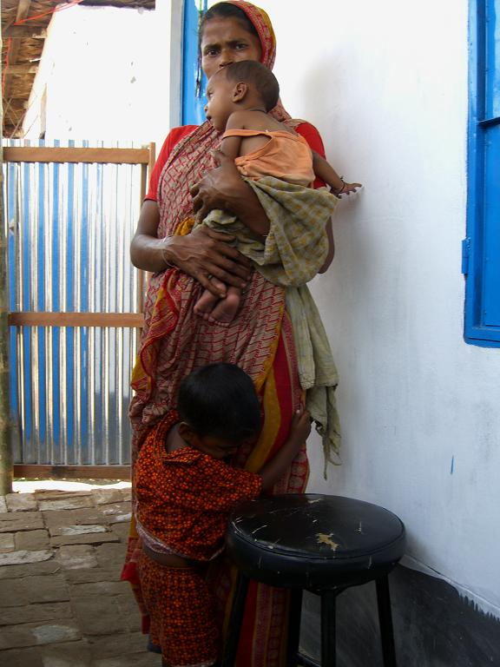
Abul Kalam is 4 years old. He lives with his mother and baby brother in a small hut in Badda, a large slum in Dhaka, Bangladesh. Abul’s father has left them and his mother Kisum can barely feed her two children. With the baby she begs on busy intersections in the city. To make sure that Abul wouldn’t wander off in her absence, she used to chain him to a bamboo pole, where he is left in the scorching sun. This is how we found him - a young handicapped child who can’t speak, frightened of the world, jaundiced and with the typical signs of malnutrition.
After careful consideration and consultations with child and health care specialists in Dhaka, the Banyan Trust has just opened a small new day centre in the slums where Abul Kalam now comes every day to enjoy special education and a daily meal. A dedicated donation from a UK sponsor has made it possible to initiate this new Banyan endeavour.
The Sanjeevani Project is a day centre in the middle of a large slum. In our newly erected building 25 children attend day
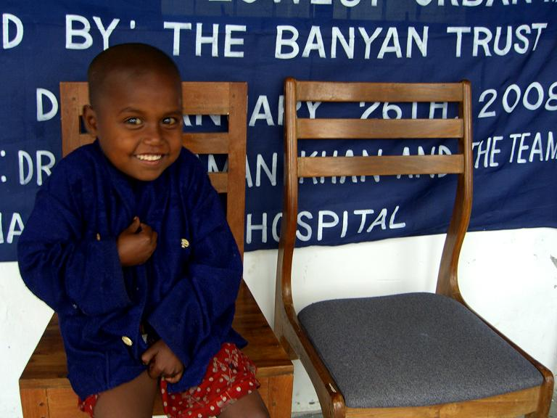

BANYAN CALCUTTA, INDIA
An important visitor had cancelled his visit on the 18th of January, so Apanjan suddenly found itself without an event. One of the children’s most popular days is by far the annual Apanjan Sports Day and it was swiftly decided by Somasree, Apanjan’s project coordinator, and her team that another sports day would make everybody happy. It gives the children a sense of occasion and they love all the preparations. The parents of the day school pupils were also excited and many people showed up to participate. It’s always fun to watch how deeply competitive the children are and how most of them will literally elbow themselves to the finish, in order to secure the applause and the prizes.
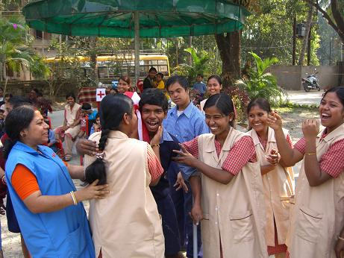
Shambu congratulated by the carers for winning a ball game.

MESSAGE FROM THE CHAIRMAN
As you can see this issue is twice as big as usual but that is simply because there is a lot to tell you - and its all good news!
To begin with, Apanjan is developing fast and like any other vibrant entity, it is appropriate to move on – towards more independence.
There are now 3 more new boys to care for as well as our established family of boys and girls who are busy learning useful practical skills together with their much needed social skills. OFFER has organised an ambitious programme for the Apanjan children under the guidance of their wonderful care team and the very gifted special educators. West Bengal now has a thriving centre of excellence for mentally challenged children.
This has allowed The Banyan Trust to approach another community needing support to get a much needed project underway and its right on the door step!
The Bangladeshi capitol Dhaka is only a 25 minute flight away from Kolkata ( there is now a new train line too ), so visiting both projects could not be easier. (Continued on page 2, column 2)

disabilities. A few have enjoyed schooling briefly, but were expelled prematurely as they lagged behind. A number of children are already showing such dramatic improvement since the opening of Sanjeevani that we have decided to enrol them into regular schools, a big step which will be closely monitored by us.
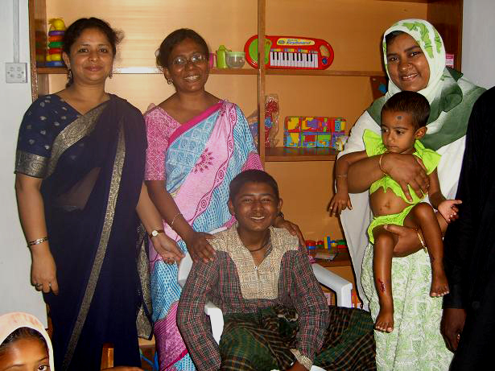
From left to right: Foujia, Nurjahan, Abu and Rabeya.
Sanjeevani employs three special educators, a project coordinator and three extra support staff who have been recruited within the local community. Our special educators were trained and recommended by the “Bangladesh Protibondhi Foundation” (Bangladesh Foundation for Handicap). The picture above shows our three educators with Abu Mia. Abu Mia is deaf and dumb, epileptic, suffers from muscular dystrophy and has learning difficulties. Every day he can be found sitting in the relentless heat with a begging bowl on a Dhaka street corner. Despite the fact that Abu’s parents need his income to help feed the family, Sanjeevani has managed to agree with them that he comes to Sanjeevani once a week, where he receives a proper meal, physiotherapy, special lessons and enjoys a safe and positive social environment. Also through our outreach programme Sanjeevani’s staff is able to keep a close eye on Abu.

(Message from the Chairman, from page 1)
Two of our Banyan trustees have had a diplomatic posting in Dhaka for some time now and by telling various people about Apanjan they have connected with other like-minded people who have guided us towards our new project. The Banyan Trust has learned so much from OFFER and Apanjan, that we feel confident enough to spread our Banyan tree further to protect and nurture some other vulnerable children too.
Local people with expertise from within the slum community in Dhaka have welcomed us and the result is our new day-care centre Sanjeevani, is already up and running within months of our receiving a very generous donation last Christmas from a trading company in the UK.
We trust you share our deep concern for the poor families in Bangladesh, which gets mentioned in the news a lot now. It is always the most needy and vulnerable who suffer most in times of famine, so we are grateful for any new donors and additional contributions for the Sanjeevani project. We can assure you that, as always, your contributions will go to Kolkata and Dhaka without administrative cost. Thank you so much for all your generous contributions in the past and let’s hope we are as successful at Sanjeevani as we are at Apanjan.

(“Banyan Dhaka Bangladesh”, from page 1)
classes, with simple lessons and stimulation, accompanied by support in feeding, washing and other daily activities which most of us take for granted. A comprehensive survey of the slum was undertaken by the Banyan Trust – in collaboration with Bangladeshi health care professionals - in order to determine the incidence of physical and mental handicap in the community. Parents of disabled children were then invited with their offspring to an assessment day. The assessment by a team of 12 professionals from the Dhaka Children’s Hospital determined which children would be able to attend the new child development centre and who would benefit from an outreach programme. As soon as the building was finished the Sanjeevani Centre opened its doors with festive activities for the students and their families.
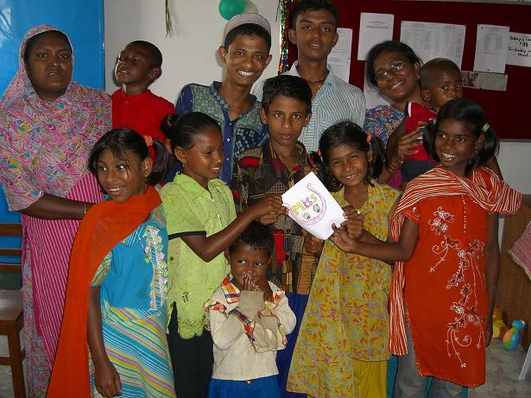
Sanjeevani’s children presenting a joint art work.
The programme is the first of its kind in Dhaka, and has attracted a great deal of attention from disability experts in the city. There is already interest in replicating the Sanjeevani approach from several reputable Bangladeshi organisations. With the centre anchored in the heart of the slum community, it also holds out the promise of changing attitudes towards disability and raising awareness about the potential of handicapped children. However, it is early days yet, and it will be vital to monitor the impact of the new centre carefully.
The prevalence of disability in Bangladesh should also not be underestimated. Our survey of the slum revealed an incidence of more than 25% disability cases amongst the families visited and participating in the questionnaire. Most Sanjeevani children have suffered exclusion from mainstream education due to their
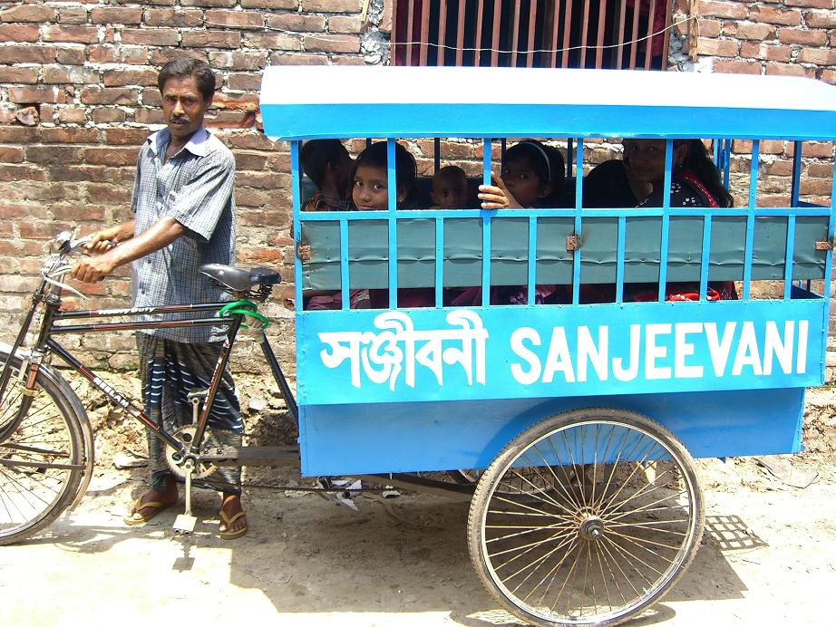
The Sanjeevani schoolbus,
the most suitable mode of transport in the narrow and bustling slum streets.

TOWARDS SUSTAINABILITY
Exploring longer-term options for the Banyan Trust
A prominent concern of all voluntary organisations is the need to work for “sustainability” in project operations in order to ensure that the longer-term prospects of the organisation in question are secured. For the Banyan Trust, this is a particular challenge given the very nature of our work, with the need to recognise that some of the most profoundly handicapped children in our care will never be economically productive in a conventional sense.
We rely heavily on the kindness and commitment of our sponsors and donors. However, that does not mean that we are omitting to explore possible ways in which to make our homes more self-sustaining and even revenue-generating. In Apanjan, the children are learning to make simple products which are offered for sale in Kolkata, including candle-holders, bookmarks and decorated note-books. Capable older children are encouraged to take an active role in simple activities such as feeding the younger children and tidying up after lessons and meals.
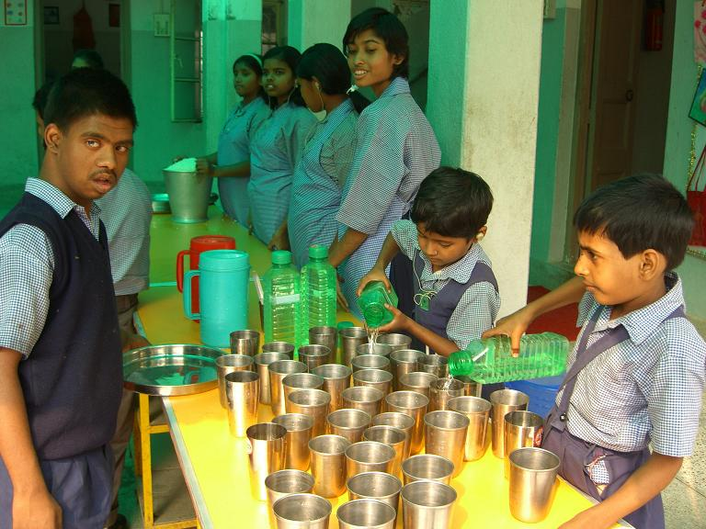
Apanjan’s children getting ready to serve lunch.
An encouraging fact with regard to Apanjan’s dependency on foreign funding is a significant increase in local contributions. India is changing rapidly and no longer the same country where Banyan started its work almost 10 years ago. Prosperity is spreading amongst the Indian middle-classes and with it comes a willingness to contribute to charitable causes within their own vicinity. For The Banyan Trust this means the welcome ability to gradually decrease our financial commitment to Apanjan, so we can now begin to extend a helping hand elsewhere, to children with special needs who desperately need our support, such as at our new Sanjeevani Project in Dhaka, Bangladesh.
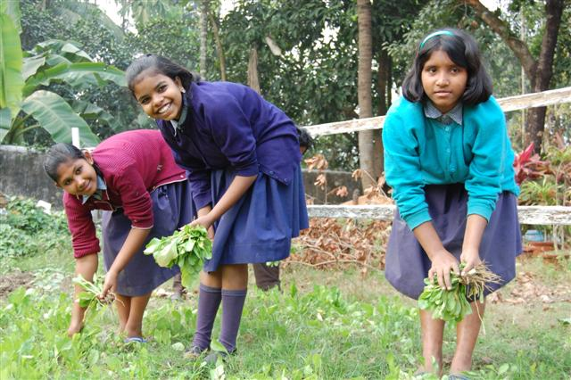
Harvesting spinach at Apanjan.
The Banyan Trust’s chosen approach is to initiate a project and get it firmly on track in close cooperation with local NGOs through regular financial commitment and close monitoring.
In Dhaka Banyan’s new Sanjeevani programme of day care may

differ from Apanjan’s concept of residential care, but it remains true to The Banyan Trust’s mission of comprehensive support for children with multiple disabilities from the poorest communities. In locating Sanjeevani in the heart of one of the most deprived slums in Dhaka, we are responding to the acute needs of the community and helping families to cope with the additional challenges of raising disabled children in such challenging circumstances.
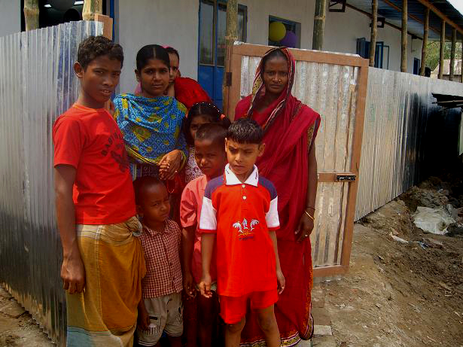
Children and their mothers in front of the Sanjeevani Centre.

Rising food prices take their toll on the poorest
Drastic increases in the price of key staples are making headlines around the world, with poor harvests and the switch to bio-fuels cited as some of the causes for this unwelcome development. Nowhere is the impact of such price rises felt so keenly as in the poorest households of developing countries, where typically 80% of income is spent on food costs alone. Through our projects in India and Bangladesh, the Banyan Trust and our partners are well-placed to witness the effects on food consumption and health which the price rises engender. In Bangladesh, the cost of rice has sky-rocketed in recent months, not least as a result of the floods and Cyclone Sidr which affected the country last year. Whilst the children attending the Sanjeevani centre are assured of one free square meal per day, the families of the children – and others in the surrounding community – have voiced their desperation at being unable to purchase sufficient food to cover their needs. (continued on page 4)

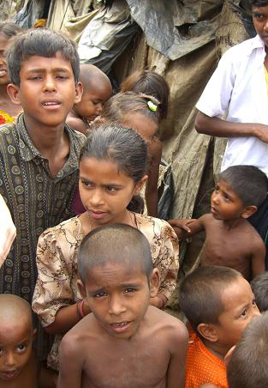
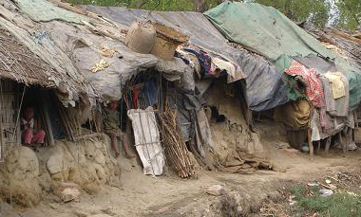

Slums in Bangladesh

SLUM’s Chairman, Chitto Halder, has been active in the area for almost 20 years. Chitto’s vast experience and invaluable contacts have made it possible for us to establish the Sanjeevani Centre at the heart of this closely knit community and immediately enjoy the much needed trust and support of the people.
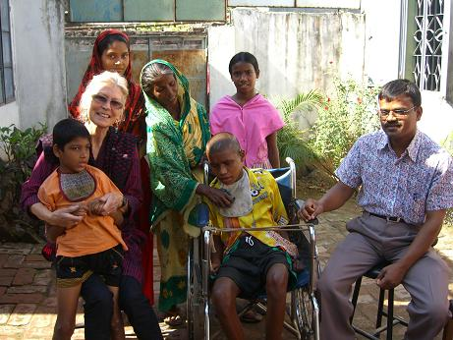
Chitto Halder (right) and Annie Larner (left) with Sanjeevani children Mamun and Amir and their mothers.

THANK YOU!
We would like to thank the following people for their kind and generous help:
- Barco, for being the best Santa.
- Graham, for always being there bookwise.
- Professor Naila Zaman Khan whose help and guidance have been so instrumental in the set-up of Sanjeevani.
- Dr Shamim Ferdous for her help in finding us our excellent staff at Sanjeevani, with the special furniture and her invaluable advice.
- Anita Peace and her family whose generosity makes an awful lot happen in their native Kolkata.
- Pat Watson for dedicating her birthday to Banyan.
- All the donors who give regularly.
- All the people who give with Gift Aid.
- The Banyan friends who collect small change.
- The youngsters who send us their cuddly toys.

(From page 3, “Rising Food Prices”)
By providing the daily meal for our children, Sanjeevani is helping to take the pressure off hard-pressed families who can therefore allocate more food to other members of the family. The imminent new (or “boro”) rice harvest in Bangladesh offers some hope of alleviating the situation. In the meantime, we are doing what we can to monitor the health and welfare of the children in the project’s care.
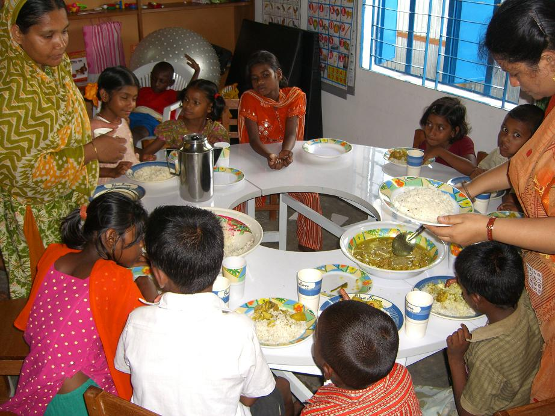
Lunch at Sanjeevani
A typical lunch at Sanjeevani consists of rice, dhal and vegetables and three times a week the children get fish, meat or eggs for their intake of protein.

WORKING TOGETHER
In Kolkata The Banyan Trust works together with a local NGO called OFFER, responsible for many other projects as well. For example, in close proximity to the Apanjan Project OFFER has also opened the Anandaghar Project for children with HIV/AIDS. Its very start was funded by The Banyan Trust through the generosity of some of our sponsors and until recently we still helped out with the logistics of OFFER’s new project. Now the Anandaghar Project stands on its own. legs and will further develop independently from Apanjan, as our focus remains the issue of disability. Sponsorship for Anandaghar is coming mainly from within India.
In Dhaka we are in partnership with a local NGO called SLUM, a small grass-roots organisation that runs a school and a vocational training project in the slum community of Badda..

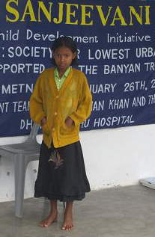
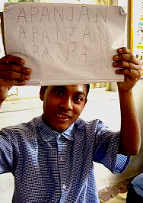
OUR WORK
Sanjeevani and Apanjan are projects of The Banyan Trust. Our mission is to offer comprehensive care to children with multiple disabilities from the poorest communities.
Our work would not be possible without the generous support of our regular sponsors.
For more information contact The Banyan Trust:
0031206648406
Or email: banyantrust.nl@club.tip.nl

This newsletter was printed courtesy of SRL Consultants

