BANYANews

Newsletter of The Banyan Trust
Year 12 Registered Charity No. 1071981 Company Limited by Guarantee No. 3610633 Winter 2011

REFLECTION AND PROJECTION
At Sanjeevani a year’s end not only brings reflection on the project’s achievements and successes, but also on its problems and the setbacks encountered. 2011 was not an easy year for Sanjeevani, particularly for the staff, who had to cope with the head teacher’s absence to attend training in the US and much missed her invaluable guidance and energy. It was their task to work even harder and to ensure the special education programme and especially the routines of Sanjeevani continued as normal for the students.
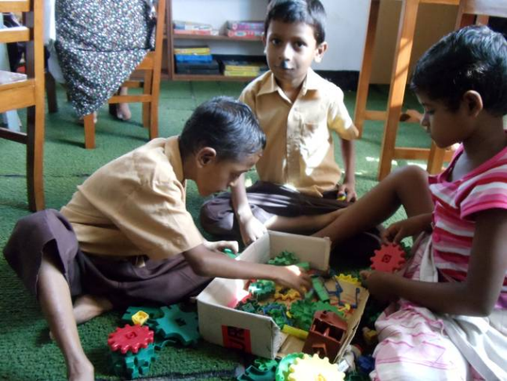
Sanjeevani’s Montessori approach means children in small groups and teachers moving around the rooms.
Rabeya Neela returned in August from a fantastic year at the Perkins School for the Blind, brimming with fresh expertise and ideas, keen to implement them within the challenging context of Sanjeevani and its children with multiple disabilities. She was appointed Director and under her competent and inspiring leadership the staff are thriving again and feel properly supported and guided by her in their daily work. The programme now offers specialist care for vision impaired children.
Looking back at 2011, there were some unsettling incidents of aggression, in particular with one student who injured several staff members and caused another student to be hospitalised in a disturbing burst of rage. (Continued on page 2, column 1)

CHAIRMAN’S MESSAGE
2011 has been an amazing year for Sanjeevani – to start with, Rabeya Neela our senior teacher, was in Boston on a post graduate course for visually impaired multi disabled children or VIMD as it is called on campus! She was at The Perkins School for the Blind, the famous institute where Helen Keller and her teacher Anne Sullivan were educated. They have a website should you want to know more.......it’s an amazing place! I went over for a few days in May for the graduation ceremony and to see for myself what help these vulnerable children need and how we could include a few more at Sanjeevani. (Continued on page 2)

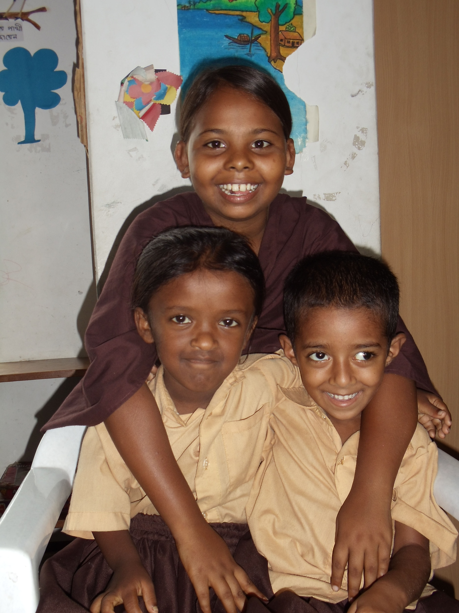
A typical day at Sanjeevani, with teacher Nighat who specialises in children with hearing impairments.

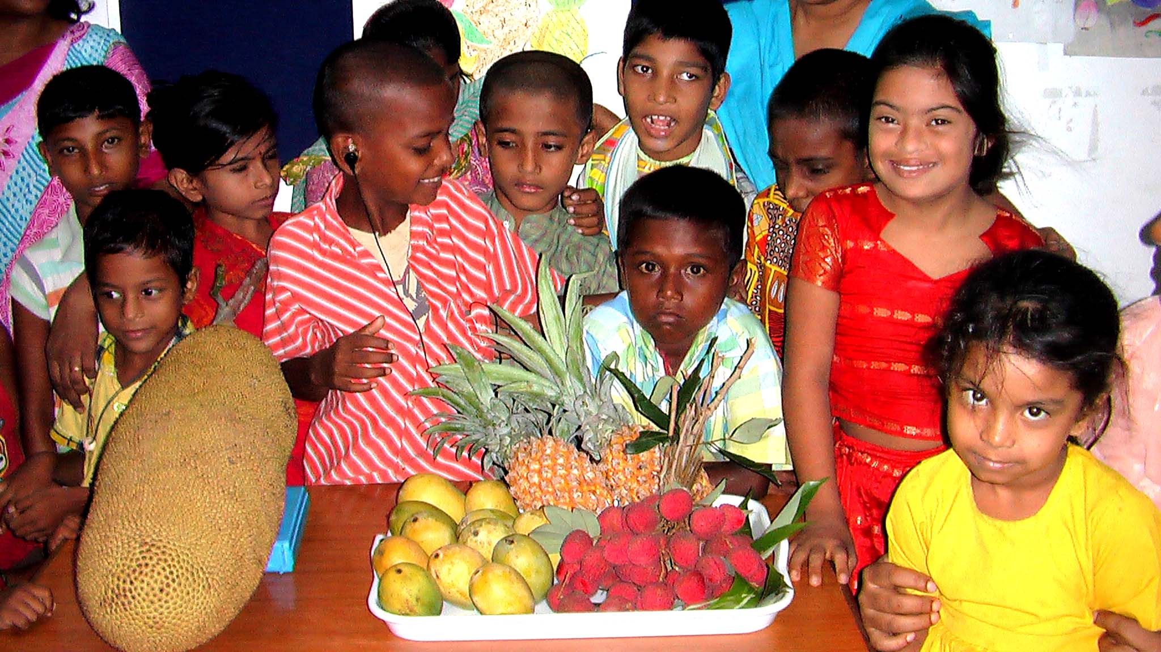

Season’s Greetings
To all our Sponsors !!

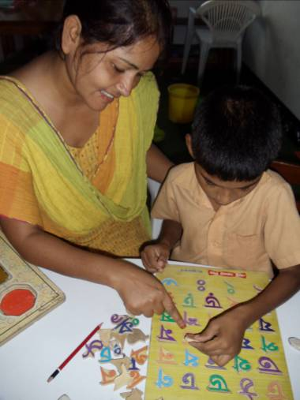

(Continued – “Reflection and Projection”)
It took four adults to control him and calm his nerves, underlining the need for adequate staff numbers.
One of Sanjeevani’s proud achievements this year was the successful transition of more and more Sanjeevani students to regular primary education at the Bright Stars Inclusive School, Sanjeevani’s partner school housed in the same building.
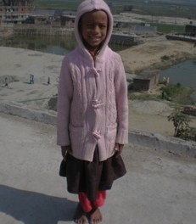
Jelli (left) and Ratri (right) now excellent students at the Bright Stars Inclusive School, who successfully made the transfer from Sanjeevani.

As in 2009, the past year proved extra challenging for the families of students - they saw the prices of food sky-rocket again to levels where they could no longer afford daily meals and began to accumulate serious debts. The Sanjeevani Centre felt compelled to temporarily reach out to these families and therefore decided in February to reinstate the Rice Bank, a tightly controlled programme of subsidised rice for the families of our children. A substantial burden on our finances, we were relieved and grateful when the Herrod Foundation stepped forward with a generous grant dedicated to this emergency service that benefits about five hundred people. (Continued on page 3, column 1)

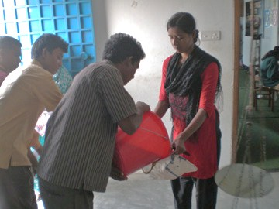
Rice distribution at Sanjeevani, March 2011

(Continued – “Message from the Chairman”)
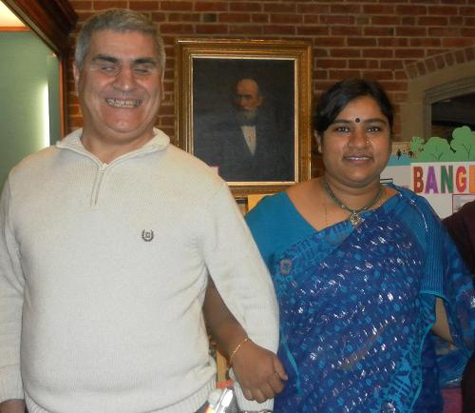
Rabeya Neela and Cafer Barkus, Coordinator of the Educational Leadership Programme at Perkins School for the Blind in Watertown, Massachusetts.
Well- it was a whirlwind tour- but I felt very welcome and once again talked with Debbie Gleeson who has visited Sanjeevani and who showed me exactly how we could benefit from their continued involvement once Rabeya was back home and getting the professional mentoring on offer from Perkins.
The International Dept. at Perkins has a network of advisors for their alumni and now there is a new Asian website for them all to use - to share ideas , problems and success stories too. This is inspirational support for our project and we can benefit from our new knowledge and share with others at the same time. In this way so many more children will get the education that equips them to manage their disability - we don’t have to expand our project so it becomes a big institution, we simply share our skills and experience with other teachers and community workers so that so many more children will benefit and the pyramid of knowledge/education spreads outside the Badda slum and way beyond, while Sanjeevani itself stays small and within its own community. The concept is to expand the skills and insight from Sanjeevani while it stays serving the local families for whom it is a sanctuary. At Perkins I met an amazingly energetic, imaginative group of young women who did all their work in their second language, used laptop computers for their assignments, played with lots of different children with individual needs, sang ,danced and talked with parents who were learning about their role in the care programme for their child. I had meetings with special educators and their admin staff who pulled as a team, respecting the individual needs of others and allowing everyone, staff and students alike to develop their skills at their own pace and face the various challenges presented to them without being overwhelmed. First Class education and social interaction indeed.

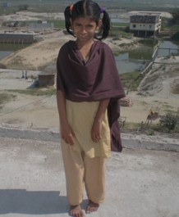

“Continued – “Reflection and Projection”
The Rice Bank is still running, because prices have not eased, unlike 2009 when the Rice Bank could be stopped after six months due to good harvests. Continuation in 2012 is uncertain as The Banyan Trust has not yet been able to secure the extra funds needed for the subsidised rice programme.
A worldwide economic crisis does not leave a small project like Sanjeevani untouched. Unsurprisingly, as with most other charities, the Banyan Trust has seen its group of regular sponsors shrink and thus annual income, which means 2012 will not see an expansion of Sanjeevani’s activities. Instead it will be a quiet year of consolidation, whilst ever improving the quality of the services offered. The students of Sanjeevani are lucky to still be able to count on enough sponsors who ensure that these children with special needs living in such difficult circumstances can continue to come to their beloved day centre everyday in 2012.
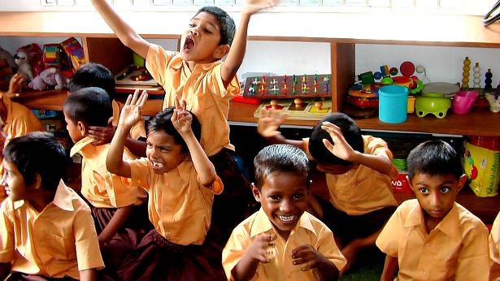

WHY BANGLADESH?
Emerging economic tigers, rapidly growing middle-classes, double digit growth, are just a few terms coined daily in our media when describing the current economic success stories of many Asian countries, such as India, Indonesia, Vietnam and Thailand. Development aid programmes are being transformed into fruitful trading partnerships between former donors and beneficiaries and at present the focus of international development is under review in all European capitals. Tough choices will have to be made due to our embattled economies and despite recent political pledges to ring fence development aid, it looks inevitable the entire sector will need recalibration in the near future. Discussions on internet forums and in the media are growing louder with regard to the choice of certain countries still receiving generous aid packages
(Continued on page 4, column 1)
(Continued – “Message from the Chairman”)
This experience that Rabeya herself instigated, will lead to so much more being achieved in Bangladesh. With Rabeya as newly appointed Director of Sanjeevani we now have a team leader who is truly inspirational and we should all be very proud of her and her team who are eager to learn from her experience in Boston. The other main area for development will be our parents. When we started in Dhaka they were confused, suspicious and unconvinced that their kids could change their behaviour, let alone learn anything useful! Well that’s changing and workshops have started, mothers are helping each other and some fathers too have become more positive about the future for their child.

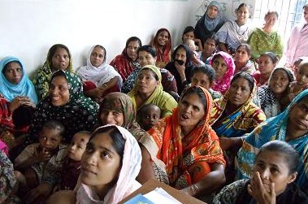
Sanjeevani workshop for parents of children with special needs.

Meanwhile here in London, I had an opportunity recently to bid for funding specifically for the development of our educational programme, which I can tell you about in the spring issue – but it looks like our progress as a centre of excellence is assured for a while at least.
That is all the exciting news, what we have to remember now is how slowly real change needs to be, so that people absorb the benefit and don’t get scared away with the momentum of it all. Rabeya sends us photos of happy events as they occur – if you would like to see these for yourself just send me your email address and I can make up a Banyan donor group and simply forward them onto you all. I look forward to hearing from you: annie.banyan@talktalk.net Please don’t forget that none of this development could happen without your continued support. Your consistent giving is what enables Sanjeevani to survive despite the dire fiscal situation that we cannot avoid wherever we are. Thank you so very much and may 2012 be a very good year for you too - for Sanjeevani’s progress - just watch this space!
Annie Larner,
Chairman of the Banyan Trust

(“Why Bangladesh?”)
It may be the proverbial drop in a vast ocean, but in the difficult lives of Sanjeevani’s children it is the drop that makes the difference between life and death, misery and happiness, dignity and utter neglect.

(Continued – “Why Bangladesh?”)
from countries plagued by recession and severe budget cuts. In this context we would like to briefly take a look at Bangladesh, a country listed 146th on the UNDP Development Index, below many African countries. Being the most densely populated country on earth, Bangladesh barely has enough food to feed its people. Every year regions are struck by famine, “mongla” as it is called in Bengali, due to either droughts in the north or severe floods during the heavy monsoon seasons ruining the harvests. Situated in the delta of the Indian subcontinent’s great rivers, it is not uncommon for 95% of the country to flood during those difficult months. Whilst worldwide the debate is raging about the effects and even existence of climate change, Bangladesh is already losing the battle against the forces of nature with evermore coastal areas permanently submerging under water, displacing large amounts of people. Often seeking refuge and new opportunities in the capital Dhaka, these people end up in the city’s vast slums, where hardship awaits them. For their children there is scarce provision of education and hardly any access to proper health care. To complement the family’s income they are found begging in the streets and their childhood comes to an end at a very early age. There is even less provision of care and services for children with special needs, the most vulnerable group. This is where the Banyan Trust enters the picture with its Sanjeevani Centre for Child Development, which offers professional support and much-needed services to children with multiple disabilities living in a large slum area of Dhaka.

A BIG THANK YOU!
- Rupert W for a surprise donation.
- A & M Geisler - Martins.
- Margaret W for her party gift cheques.
- The Colman Trust for Rice Bank support.
- JMLM for a generous donation.
- Alexandra & Leo Cohen.
- David LS for his introduction to new sponsors.
- Giles Junior School Stevenage for the
biggest cheque yet!!
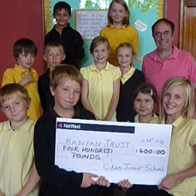

THE BANYAN TRUST
The Banyan Trust was founded in 1998 with the aim to provide comprehensive care to children with special needs from the poorest communities in India, Bangladesh and elsewhere.
From 1999 – 2009 we initiated, developed and funded the Apanjan Project in Calcutta, India – a residential and educational project for children with multiple disabilities, which has grown financially independent from The Banyan Trust.
In 2008 the Sanjeevani Centre for Child Development was opened at the heart of a large slum community in Dhaka, Bangladesh.
In 2010 the Banyan Trust helped our local partner in Bangladesh establish an innovative programme of inclusive primary education,
a programme successfully integrated with the Sanjeevani Centre.
A sure path to a better future, that’s our motto.
Our work would not be possible without the consistent and generous support of our regular sponsors
For more information please contact the Banyan Trust.
Phone: 01438 358500. Or email us at: banyantrust@gmail.com
Our website: www.banyantrust.com



